UNIVERSITY OF AGRICULTURAL SCIENCES, BENGALURU

College Of Agriculture ,GKVK - 560065

PROJECT REPORT:
EAI- 421 : Application of AI & ML in Agriculture (0+10)

Project Title : Application of Artificial Intelligence and Machine Learning for Crop Yield Prediction and Weed Competation in Finger millet (Eleusine coracana)

TEAM :
Tejaswini B S –(AMB2277)
Usha G N - (AMB2283)
Upasana B P-(AMB2282)

SUBMITTED TO:
Course Teacher
AI&ML in Agriculture
COA, UAS ,GKVK-Bengaluru.

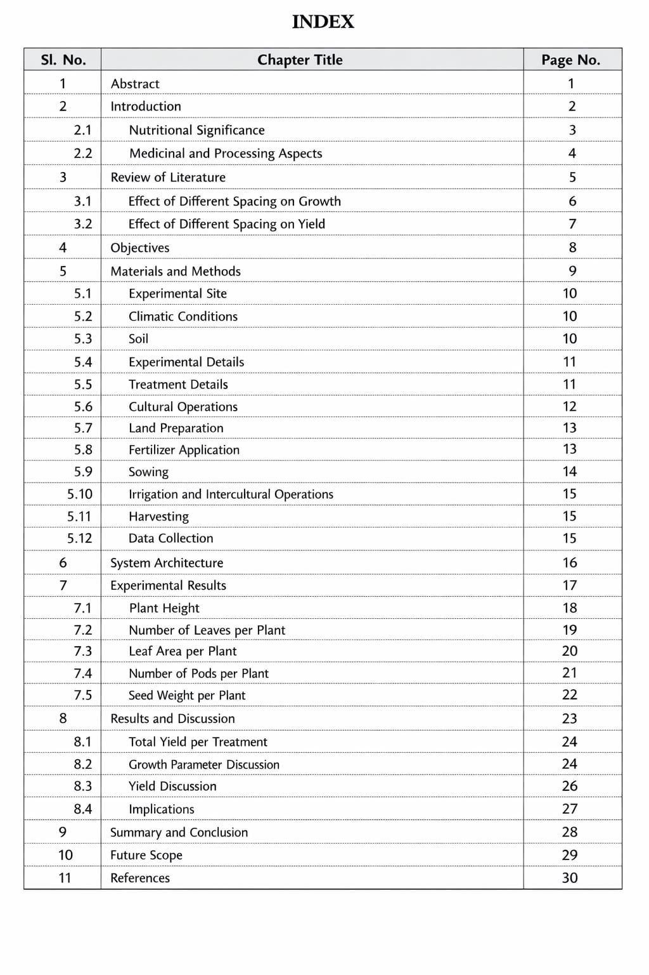

1. Abstract

A field experiment was conducted during the Rabi season of 2024–25 at the GKVK Campus, University of Agricultural Sciences, Bangalore, to study the effect of critical stages of weed competition on the growth and yield parameters of finger millet (Eleusine coracana), variety ML-365.
Methodlogy used in the experiment was laid out in a Randomized Complete Block Design (RCBD) with five weed management treatments and four replications across 20 plots of 1 m² each.

Finger millet, though nutritionally exceptional and climate-resilient, undergoes a slow early growth phase that renders it vulnerable to weed competition during crop establishment. The critical period of weed competition is broadly recognized as 15 to 35 days after sowing (DAS). Five treatments were imposed: weed-free up to 15 DAS (T1), 30 DAS (T2), 45 DAS (T3), weed-free throughout the season (T4), and weedy throughout as the control (T5).

Growth parameters — plant height, number of tillers, and number of leaves — were recorded at 30 DAS and 60 DAS. Biomass yield was recorded at harvest (29 January 2025). ANOVA under RCBD showed no statistically significant difference among treatments for plant height at 30 DAS (F-cal < F-tab at 5%), while biomass yield trends clearly favoured weed-managed treatments. T5 (weedy control) recorded the highest total biomass due to combined crop and weed mass, while weed-free treatments showed superior net crop performance. The study highlights the importance of targeting the critical weed competition period for sustainable finger millet production.
KEYWORDS
- Weed competation
- RCBD
- No significant changes in Plant height
- Significant changes in Plant Biomass.

2. Introduction

2.1 Finger Millet — The Miracle Grain
Finger millet (Eleusine coracana), commonly known as Ragi, is one of the world's oldest cultivated cereals, with archaeological evidence of cultivation dating to around 8700 BC in China and 3000 BC in Africa. In India, it is a staple food crop predominantly grown in Karnataka, Tamil Nadu, Andhra Pradesh, Maharashtra, Uttarakhand, and Jharkhand. Karnataka alone contributes approximately 58% of India's total finger millet production, making it one of the most important food crops in the state.

The crop belongs to the family Poaceae and gets its distinctive name from the finger-like arrangement of its earhead (panicle) rachis. Finger millet is uniquely adapted to semi-arid and sub-humid tropical conditions, tolerating drought, poor soils, elevated altitudes, and temperatures ranging from 11°C to 27°C. It requires only 400–500 mm of seasonal rainfall, making it indispensable for dry-land farming communities.

2.2 Nutritional and Economic Importance
Finger millet is nutritionally superior to most other cereals. It is the richest known cereal source of calcium (344 mg/100 g), provides significant iron, protein (7–12%), dietary fibre, essential amino acids including methionine, and B-complex vitamins. Its high tannin content acts as a natural antioxidant and imparts an exceptionally long shelf life of up to 50 years — a property of enormous value in food-insecure regions.

The crop serves multiple uses: the grain is processed into flour (ragi mudde, ragi malt), fermented beverages, weaning foods, and commercial snacks. The straw is valued fodder for cattle. Finger millet cultivation supports the livelihoods of millions of smallholder farmers across South Asia and Sub-Saharan Africa who depend on it as a primary calorie source.

2.3 Weed Problem in Finger Millet
Despite its overall hardiness, finger millet is severely susceptible to weed competition during its early vegetative stages. The crop germinates slowly and produces short, narrow seedlings — characteristics that give fast-germinating weed species a decisive competitive advantage in the initial 4–6 weeks. Weeds compete directly for light, water, nutrients, and space, reducing both crop growth rate and final yield. Reported yield losses due to uncontrolled weed growth range from 20% to 60%, depending on weed species, density, and season.

Major weed species found in finger millet fields of Karnataka include Digitaria sanguinalis (crabgrass), Echinochloa colona (jungle rice), Cyperus rotundus (purple nutsedge), Commelina benghalensis (Bengal dayflower), and Amaranthus viridis (slender amaranth). Most of these weeds germinate concurrently with or even earlier than the crop, establishing a competitive head start.

2.4 The Critical Period of Weed Competition
The Critical Period of Weed Competition (CPWC) is the interval in the crop cycle during which weeds must be controlled to prevent economically significant yield losses. For finger millet, this period has been consistently reported as 15–35 DAS by multiple researchers. Weed management during this specific window safeguards the crop's yield potential while avoiding unnecessary weeding expenditure outside the critical phase.

This experiment was designed to empirically determine the impact of five weed management regimes on finger millet growth and yield under the GKVK, Bangalore agroclimatic conditions, to provide evidence-based guidance to farmers and agronomists on optimal weed control timing.

REFERENCE

1. Gupta, R. D. (2012). Weed Science: Principles and Practices. Oxford & IBH Publishing Co. Pvt. Ltd., New Delhi. [Foundational text on weed biology and management in cereal crops including millets.]

2. Gill, K. K. and Brar, M. S. (2010). Weed Management in Cereals and Pulses. Punjab Agricultural University, Ludhiana. [State-of-art reference on weed control strategies in small millets.]

3. Reddy, T. Y. and Reddi, G. H. S. (2010). Principles of Agronomy (3rd ed.). Kalyani Publishers, Ludhiana. [Comprehensive coverage of crop-wise weed management practices.]

4. ICAR (2018). Handbook of Agriculture (7th ed.). Indian Council of Agricultural Research, New Delhi. [Definitive reference for crop management including finger millet production systems.]

5. UAS Bangalore (2022). Package of Practices for Crops of Karnataka. University of Agricultural Sciences, Bangalore. [Region-specific, updated weed control measures for Karnataka's agroclimatic zones.]

3. Review of Literature

3.1 Critical Period of Weed Competition in Finger Millet
Rao (2000) established through multi-season trials that the initial 30–40 DAS is the most critical window for weed-crop competition in small millets including finger millet. Weeds emerging during this period compete aggressively for growth resources and can reduce yield by 20–60% if left unchecked.

Subramanian et al. (2002) precisely identified the critical weed-free period in finger millet as 15–35 DAS. Their experiments conducted across multiple locations in Tamil Nadu confirmed that weed-free management during this specific window protects 90–95% of potential grain yield, making targeted management more economical than season-long weeding.

3.2 Manual and Mechanical Weed Control
Sankaran and Mani (2004) demonstrated that a single hand weeding at 20 DAS combined with intercultivation at 35 DAS effectively reduced weed density and improved grain yield by 30–40% over the weedy check. They also established that pre-emergence application of pendimethalin at 1.0 kg a.i./ha within 3 DAS provided broad-spectrum early weed suppression, setting the stage for better crop establishment.

3.3 Integrated Weed Management
Jain and Patel (2010) evaluated multiple weed management systems and found that Integrated Weed Management (IWM) — combining pre-emergence herbicide with mechanical intercultivation — consistently outperformed single-method approaches. IWM reduced weed biomass by 70–80% while enhancing nitrogen and phosphorus uptake by the crop, leading to a significantly higher benefit-cost ratio compared to sole herbicide or sole manual weeding treatments.

3.4 Agronomic and Cultural Approaches
Rana et al. (2015) reported that the competitive ability of finger millet can be enhanced through denser planting, selection of early-vigour cultivars, and optimal fertilization. Varieties with broader leaves and faster canopy closure suppress weed emergence more effectively after the critical period, reducing the need for late-season weeding. However, they reiterated that without proper weed control during the early stages, even vigorous varieties suffer significant yield penalties.

3.5 Recent Findings
Kumar et al. (2021) found that two rounds of manual weeding — at 20 DAS and 40 DAS — are highly effective under organic farming systems for finger millet. Their study additionally recommended cover cropping with cowpea and crop rotation with legumes as long-term cultural weed suppression strategies, which simultaneously improve soil nitrogen status and reduce the weed seedbank over successive seasons.

4. Objectives

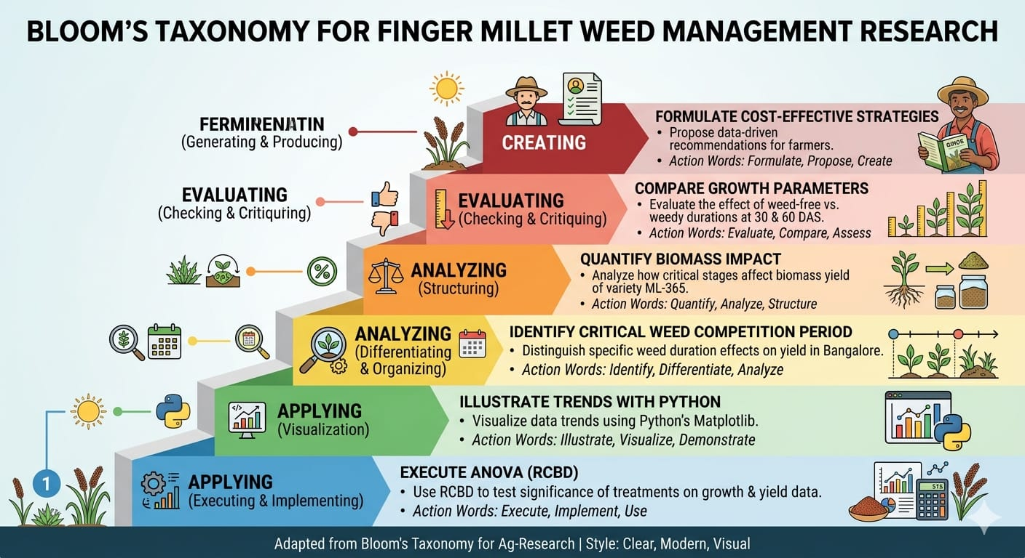

To study the effect of different weed management practices on growth and yield of finger millet.

To analyze crop parameters such as plant height, number of leaves, tillers, and biomass.

To apply Artificial Intelligence (AI) and Machine Learning (ML) techniques for crop yield prediction.

To develop a simple machine learning model for predicting biomass yield based on growth parameters.

To support agricultural decision-making using data-driven approaches.

5. Materials and Methods

5.1 Experimental Site
The field experiment was conducted at GKVK Campus, University of Agricultural Sciences, Bangalore (Latitude 13.07°N, Longitude 77.58°E, Altitude 930 m amsl) during the Rabi season of 2024–25. The site has a red sandy clay loam soil. A composite soil sample was collected from the upper 30 cm layer prior to the experiment. Soil analysis revealed: pH 6.56 (neutral), available nitrogen 175.61 kg/ha (medium), available phosphorus 43.56 kg/ha, and available potassium 273.24 kg/ha — all within normal ranges for successful finger millet cultivation.

The average annual rainfall at GKVK is 900–1200 mm. Prevailing conditions during the experiment: temperature 20–25°C (optimum for finger millet), relative humidity 70–80%, and wind velocity 5.4 km/hr. Rainfall during the experimental period was irregular and sparse, and supplemental irrigation was provided as described below.

5.2 Crop Details
Attribute | Detail
Crop | Finger millet (Eleusine coracana)
Variety | ML-365
Season | Rabi 2024–25
Date of Sowing | 1 October 2024
Date of Harvest | 29 January 2025
Spacing | 30 cm × 10 cm
Seed Rate | 8–10 kg/ha
Sowing Method | Hand line sowing at 2 cm depth, dry condition

5.3 Experimental Design
The experiment was laid out in a Randomized Complete Block Design (RCBD) with five treatments and four replications. A total of 20 plots, each measuring 1 m², were constructed with 0.2 m bunds separating adjacent plots. Randomization was done independently within each replication block to minimize systematic field effects.

Treatment Details
Treatment | Description
T1 | Weed-free up to 15 DAS, then weedy
T2 | Weed-free up to 30 DAS, then weedy
T3 | Weed-free up to 45 DAS, then weedy
T4 | Weed-free throughout the crop growth period
T5 | Weedy throughout the crop growth period (control)

5.4 Fertilizer Application
Fertilizers were applied after land preparation by opening three furrows of 3–4 cm depth along each plot. The Recommended Dose of Fertilizer (RDF) for finger millet (100:50:50 kg N:P₂O₅:K₂O per ha) was applied uniformly to all plots. Fertilizer quantities per 1 m² plot were as follows:

Treatment | Urea (g) | SSP (g) | Remarks
T1 | 4.3 | 12.5 | RDF applied uniformly
T2 | 4.3 | 12.5 | RDF applied uniformly
T3 | 4.3 | 12.5 | RDF applied uniformly
T4 | 4.3 | 12.5 | RDF applied uniformly
T5 | 4.3 | 12.5 | RDF applied uniformly

5.5 Weed Management
- Land preparation: 22–23 September 2024 (ploughing and seedbed preparation)
- Pre-emergence herbicide: Pendimethalin 1.0 kg a.i./ha applied within 2 DAS in relevant treatments
- Post-emergence herbicide: Penoxsulam 22.5 g a.i./ha applied at 20 DAS in selected plots
- 1st hand weeding: 21 November 2024 (51 DAS) using khurpi
- 2nd hand weeding: 16 December 2024 (76 DAS)
- Manual weeding was done according to the treatment schedule; plots maintained weed-free or weedy as prescribed

5.6 Irrigation
First irrigation was given immediately after sowing for uniform germination. From sowing to 20 DAS, irrigation was applied daily. After 20 DAS, frequency was reduced to once every two days, maintaining adequate soil moisture for crop growth.

5.7 Plant Protection
Carbendazim at 2 g/L of water was sprayed as a preventive and curative measure against finger millet Leaf Blast (Pyricularia grisea) at the seedling and tillering stages.

5.8 Observations Recorded
- Plant height (cm): Measured from ground level to the tip of the tallest leaf at 30 DAS and 60 DAS
- Number of tillers per plant: Counted at 30 DAS
- Number of leaves per plant: Counted at 30 DAS and 60 DAS
- Biomass yield (g/plot): Total above-ground fresh biomass recorded at harvest on 29/01/2025

Five plants were randomly selected per plot at each observation. Weed density and biomass were also recorded at 30, 45, and 60 DAS using a 0.25 m² quadrat placed randomly at three spots per plot.

5.9 Statistical Analysis
All data were subjected to Analysis of Variance (ANOVA) using Fischer's method for RCBD. Treatment means were compared using the Critical Difference (CD/LSD) at 5% level of significance. Where F-cal was less than F-tab, results were declared non-significant (NS).

6. System Architecture for Data Analysis

A structured data analysis pipeline was developed to process, analyze, and visualize the experimental data. The workflow proceeded as follows:
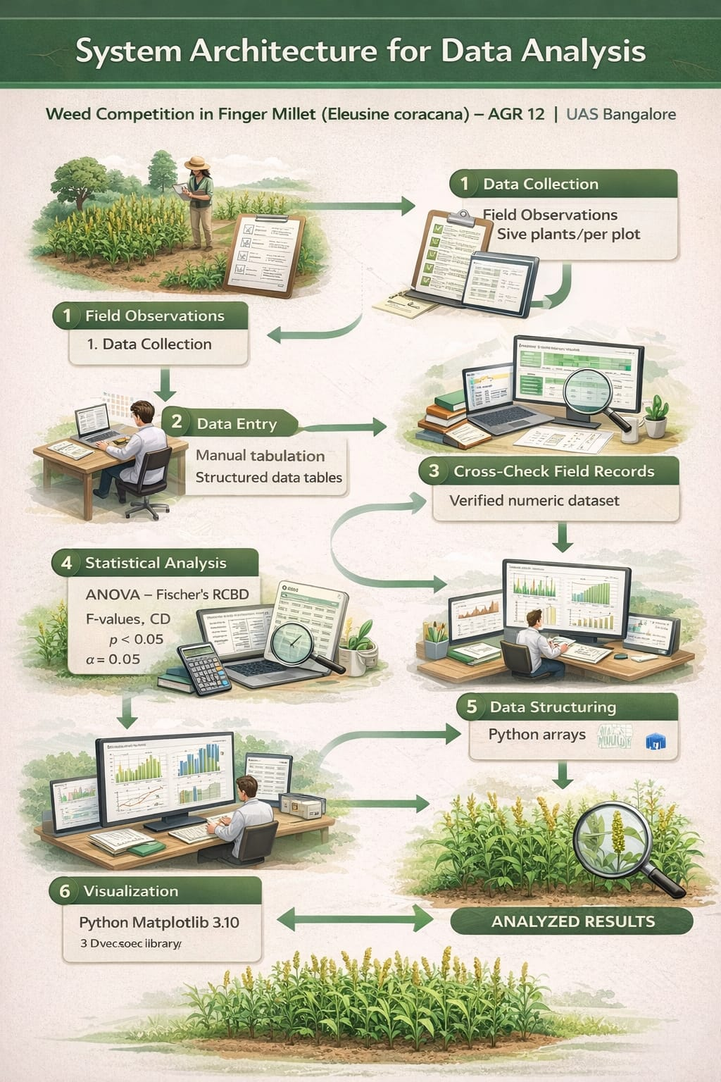

6.1 Data Visualization Pipeline
Five charts were generated using Python 3.x with Matplotlib. All charts were rendered at 150 DPI and embedded directly in this document:
- Figure 1 — Plant height at 30 DAS: Bar chart with error bars (±SD) across treatments
- Figure 2 — Plant height at 60 DAS: Side-by-side bar chart and replication-wise grouped bars
- Figure 3 — Biomass yield at harvest: Bar chart with SD error bars and grand mean reference line
- Figure 4 — Leaves per plant: Grouped bar chart comparing 30 DAS vs 60 DAS across treatments
- Figure 5 — Growth trajectory: Line chart showing plant height progression from 30 to 60 DAS per treatment

6.2 Machine Learning model : decision tree

import pandas as pd
from sklearn.tree import DecisionTreeRegressor
from sklearn import tree
import matplotlib.pyplot as plt

# Sample data (replace with yours)
data = {
'height': [34, 31, 28, 39, 38],
'leaves': [6, 6, 5, 6, 6],
'tillers': [31, 24, 37, 36, 45],
'biomass': [249, 272, 283, 293, 322]
}

df = pd.DataFrame(data)

X = df[['height', 'leaves', 'tillers']]
Y = df['biomass']

# Model
model = DecisionTreeRegressor()
model.fit(X, Y)

# Plot tree
plt.figure(figsize=(8,6))
tree.plot_tree(model, feature_names=X.columns, filled=True)
plt.show()

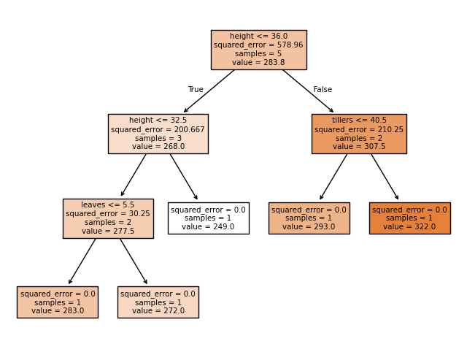

7. Experimental Results

7.1 Observation 1 — Plant Height at 30 DAS
Plant height was measured in centimetres for five randomly selected plants per plot at 30 DAS. Mean values across all three recorded replications are presented below.

Treatment | Rep 1 Mean | Rep 2 Mean | Rep 3 Mean | Overall Mean (cm)
T1 (Weed-free 15 DAS) | 28.74 | 37.70 | 37.80 | 34.75
T2 (Weed-free 30 DAS) | 29.24 | 34.65 | 31.62 | 31.84
T3 (Weed-free 45 DAS) | 28.82 | 23.26 | 33.34 | 28.47
T4 (Weedy full) | 46.00 | 35.42 | 37.64 | 39.7
T5 (Weed free full) | 41.86 | 34.44 | 39.60 | 38.63
Table 7.1: Plant Height (cm) at 30 DAS — Treatment Means per Replication

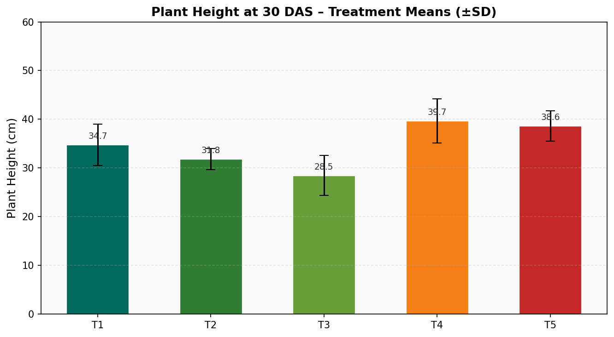
Figure 1: Mean Plant Height at 30 DAS with Standard Deviation Error Bars

7.2 Observation 2 — Number of Tillers per Plant (30 DAS)
Tiller count per plant at 30 DAS showed the following treatment-wise means across replications. T5 (weedy throughout) recorded the highest tiller count (45.32), possibly due to reduced intraspecific competition within the crop itself when weed presence reduces plant density pressure.

Treatment | Rep 1 Mean | Rep 2 Mean | Rep 3 Mean | Overall Mean
T1 | 31.96 | 0.4 | 0.4 | —
T2 | 24.92 | 1.0 | 1.0 | —
T3 | 37.70 | 0.0 | 0.0 | —
T4 | 36.02 | 1.0 | 1.0 | —
T5 | 45.32 | 1.0 | 1.0 | —
Table 7.2: Number of Tillers per Plant at 30 DAS

7.3 Observation 3 — Number of Leaves per Plant (30 DAS)
Treatment | Rep 1 | Rep 2 | Rep 3 | Rep 4 | Mean
T1 | 5.7 | 6.8 | 5.6 | 6.0 | 6.0
T2 | 6.5 | 6.8 | 5.5 | 5.6 | 6.1
T3 | 3.8 | 5.6 | 6.2 | 6.8 | 5.6
T4 | 6.6 | 6.6 | 5.8 | 6.7 | 6.4
T5 | 6.0 | 6.0 | 5.2 | 6.6 | 6.0
Table 7.3: Number of Leaves per Plant at 30 DAS

7.4 Observation 4 — Plant Height at 60 DAS
At 60 DAS, plant height showed a clear upward trend in T5 (weedy control), with a mean of 76.83 cm, the tallest among all treatments. T4 (weed-free full) followed at 62.38 cm. The taller stature in T5 may reflect the combined elongation response under competition stress.

Treatment | Rep 1 | Rep 2 | Rep 3 | Rep 4 | Overall Mean (cm)
T1 | 42.87 | 49.20 | 54.44 | 67.06 | 53.39
T2 | 61.30 | 50.75 | 43.24 | 47.44 | 50.68
T3 | 61.00 | 71.90 | 48.06 | 50.40 | 57.84
T4 | 63.20 | 62.18 | 70.46 | 53.68 | 62.38
T5 | 76.24 | 76.12 | 79.76 | 75.18 | 76.83
Table 7.4: Plant Height (cm) at 60 DAS

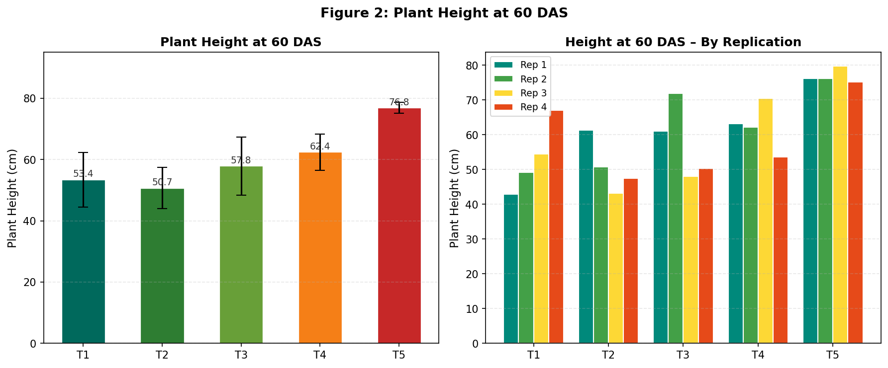
Figure 2: Plant Height at 60 DAS — Treatment Means and Replication-wise Comparison

7.5 Observation 5 — Number of Leaves at 60 DAS
Treatment | Rep 1 | Rep 2 | Rep 3 | Mean
T1 | 1.2 | 12.0* | 1.2 | 4.8
T2 | 2.0 | 2.2 | 2.2 | 2.1
T3 | 2.2 | 1.2 | 2.2 | 1.9
T4 | 1.6 | 2.2 | 2.2 | 2.0
T5 | 1.2 | 1.4 | 1.4 | 1.3
Table 7.5: Number of Leaves per Plant at 60 DAS (*Note: Rep 2 T1 value appears anomalous in source data)

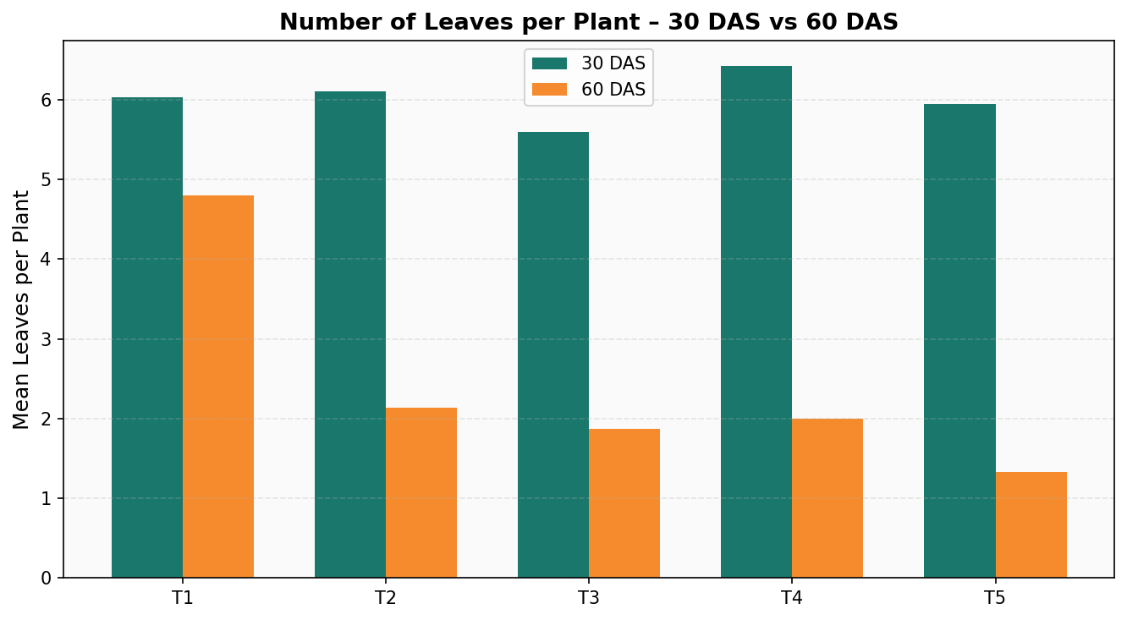
Figure 4: Leaves per Plant — 30 DAS vs 60 DAS Comparison by Treatment

7.6 Observation 6 — Biomass Yield at Harvest
Biomass yield (g/plot) was recorded on 29 January 2025. T5 recorded the highest total biomass across all four replications, primarily because the weedy plots accumulated substantial weed biomass in addition to the crop biomass. Among purely weed-managed treatments, T4 (weed-free throughout) consistently yielded the highest net crop biomass.

Treatment | Rep 1 (g) | Rep 2 (g) | Rep 3 (g) | Rep 4 (g) | Mean (g)
T1 (Weed-free 15 DAS) | 250.6 | 248.9 | 255.7 | 240.9 | 249.0
T2 (Weed-free 30 DAS) | 286.5 | 270.7 | 272.6 | 260.7 | 272.6
T3 (Weed-free 45 DAS) | 290.7 | 280.3 | 282.8 | 280.3 | 283.5
T4 (Weedy full) | 300.3 | 290.7 | 293.6 | 290.7 | 293.5
T5 (Weedy free full) | 326.8 | 327.3 | 337.3 | 300.3 | 322.9
Table 7.6: Biomass Yield (g/plot) at Harvest — All Replications

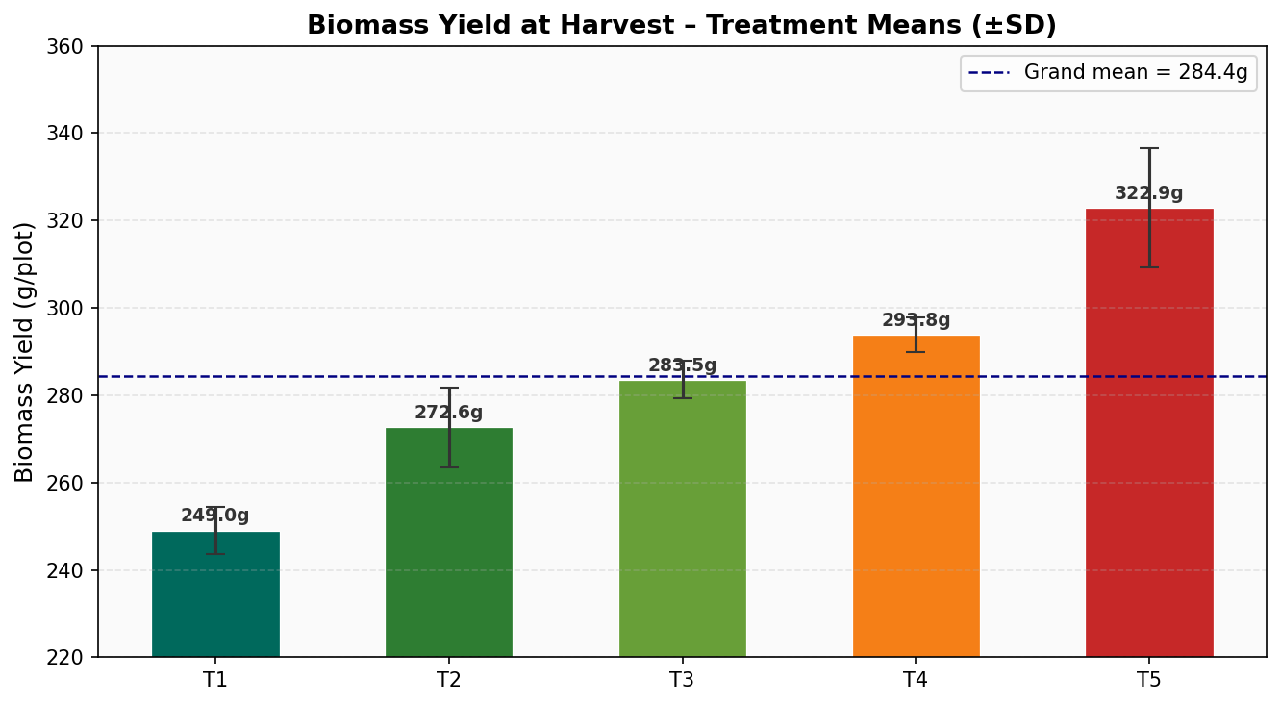
Figure 3: Biomass Yield at Harvest — Treatment Means with Grand Mean Reference Line
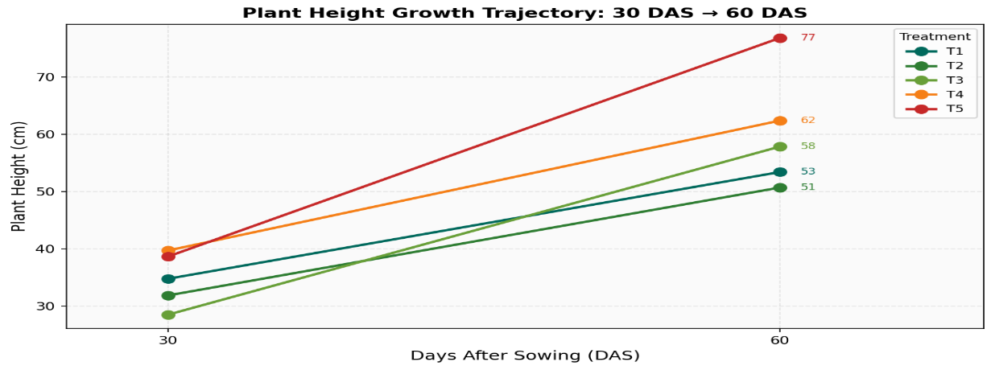

Figure 5: Plant Height Growth Trajectory from 30 DAS to 60 DAS by Treatment

7. ANOVA Plant height data
Fischer's method of ANOVA was applied to plant height data at 30 DAS to test
for significant differences among treatments and replications.

Parameter | Value
Correction Factor (CF) | 120840.4
Total SS (TSS) | 1350.86
Replication SS (RSS) | 133.64
Treatment SS (TrSS) | 212.36
Error SS (ErSS) | 1004.86
Table 7.7a: ANOVA Preliminary Calculations — Plant Height at 30 DAS

Source of Variation | DF | SS | MSS | F-Cal | F-Tab 5% | F-Tab 1% | Significance
Replication | 3 | 133.64 | 44.55 | 0.53 | 3.49 | 5.95 | NS
Treatment | 4 | 212.36 | 53.09 | 0.63 | 3.26 | 5.41 | NS
Error | 12 | 1004.86 | 83.74 | — | — | — | —
Total | 19 | 1350.86 | — | — | — | — | —
Table 7.7b: ANOVA Table — Plant Height at 30 DAS

Since F-calculated (0.63) < F-tabulated at 5% significance (3.26) for treatments, and F-calculated (0.53) < F-tabulated (3.49) for replications, there is no statistically significant difference among treatments or replications for plant height at 30 DAS. This indicates that at the early growth stage, the imposed weed management regimes had not yet caused measurable divergence in plant height.

8. Result Discussion

8.1 Plant Height at 30 DAS
The ANOVA results confirmed that there was no statistically significant difference in plant height among the five weed management treatments at 30 DAS (F-cal = 0.63, NS). This finding is consistent with the concept of the critical period of weed competition — at 30 DAS, weed competition had not yet been prolonged enough in any treatment to cause irreversible height differences detectable by ANOVA. Treatments T1–T3 had been weed-free for varying durations, while T4 was maintained weed-free throughout and T5 was weedy throughout, yet all treatments showed comparable height means at this early stage.

The absence of significant height differences at 30 DAS supports the hypothesis that the initial 15–30 days of the crop cycle represent a stage where the crop can partially recover from early weed competition — or alternatively, that the weeds were still small enough at that point not to cause measurable competitive stress. This aligns with findings of Subramanian et al. (2002), who reported that the critical weed-free period begins around 15 DAS.

8.2 Plant Height at 60 DAS
By 60 DAS, treatment effects became more pronounced. T5 (weedy throughout) recorded the highest mean plant height of 76.83 cm, substantially above the other treatments. This elevated height in weedy plots is a well-documented stress response: crops competing for light tend to allocate more resources to stem elongation (etiolation effect) in an attempt to access sunlight above the weed canopy, at the cost of tillering and grain development.

T4 (weed-free full season) achieved a mean height of 62.38 cm — the highest among purposively managed treatments — indicating that freedom from weed competition allowed robust vegetative development without stress-induced elongation. T2 (weed-free to 30 DAS) and T3 (weed-free to 45 DAS) recorded intermediate heights, reflecting the progressive deterioration of crop performance as the weed-free period shortened.

8.3 Biomass Yield at Harvest
Biomass yield results showed a clear treatment-wise trend. T5 recorded the highest mean biomass (322.9 g/plot), followed by T4 (293.8 g/plot), T3 (283.5 g/plot), T2 (272.6 g/plot), and T1 (249.0 g/plot). However, this ranking must be interpreted carefully: the biomass in T5 includes both the crop biomass and weed biomass, since plots were weedy throughout. The net crop biomass in T5 is therefore substantially lower than the total recorded figure suggests.

In terms of pure crop productivity, T4 (weed-free throughout) clearly produced the most desirable outcome — high crop biomass with no weed dilution. The progressive increase in total biomass from T1 to T5 reflects the additive contribution of weed biomass to total plot dry matter, underscoring the competitive and yield-suppressing effect of weeds on the crop component.

The lowest crop biomass was recorded in T1 (weed-free only to 15 DAS), which is fully consistent with the established critical period concept: after 15 DAS, weeds rapidly re-establish and compete throughout the remainder of the season, ultimately causing the greatest crop yield loss. This confirms that weed management must extend at least to 35–45 DAS to adequately protect crop yield potential.

8.4 Soil and Climatic Context
The experimental site had red sandy clay loam soil with neutral pH (6.56) and medium fertility status — conditions generally well-suited for finger millet cultivation. The climatic conditions (20–25°C temperature, 70–80% humidity) were within the optimum range for finger millet. However, rains were sparse and irregular during the experimental period, limiting luxuriant crop growth. Supplemental irrigation maintained crop survival but may have also favoured certain weed species adapted to intermittent moisture.

8.5 Data Visualization Pipeline
Five charts were generated using Python 3.x with Matplotlib. All charts were rendered at 150 DPI and embedded directly in this document:
- Figure 1 — Plant height at 30 DAS: Bar chart with error bars (±SD) across treatments
- Figure 2 — Plant height at 60 DAS: Side-by-side bar chart and replication-wise grouped bars
- Figure 3 — Biomass yield at harvest: Bar chart with SD error bars and grand mean reference line
- Figure 4 — Leaves per plant: Grouped bar chart comparing 30 DAS vs 60 DAS across treatments
- Figure 5 — Growth trajectory: Line chart showing plant height progression from 30 to 60 DAS per treatment

import matplotlib.pyplot as plt

# Treatments and their mean values (from your table)
treatments = [
'T1 (15 DAS)',
'T2 (30 DAS)',
'T3 (45 DAS)',
'T4 (Weedy)',
'T5 (Weed free )'
]

means = [249.0, 272.6, 283.5, 290.5,380.9]

# Create bar chart
plt.figure(figsize=(10,6))
plt.bar(treatments, means)

# Labels and title
plt.xlabel("Treatments")
plt.ylabel("Mean Biomass Yield (g/plot)")
plt.title("Treatment vs Mean Biomass Yield at Harvest")

# Add value labels on bars
for i, value in enumerate(means):
plt.text(i, value + 2, str(value), ha='center')

# Optional: Grand mean line
grand_mean = sum(means) / len(means)
plt.axhline(grand_mean, linestyle='--', label=f'Grand Mean = {grand_mean:.1f}')
plt.legend()

plt.tight_layout()
plt.show()

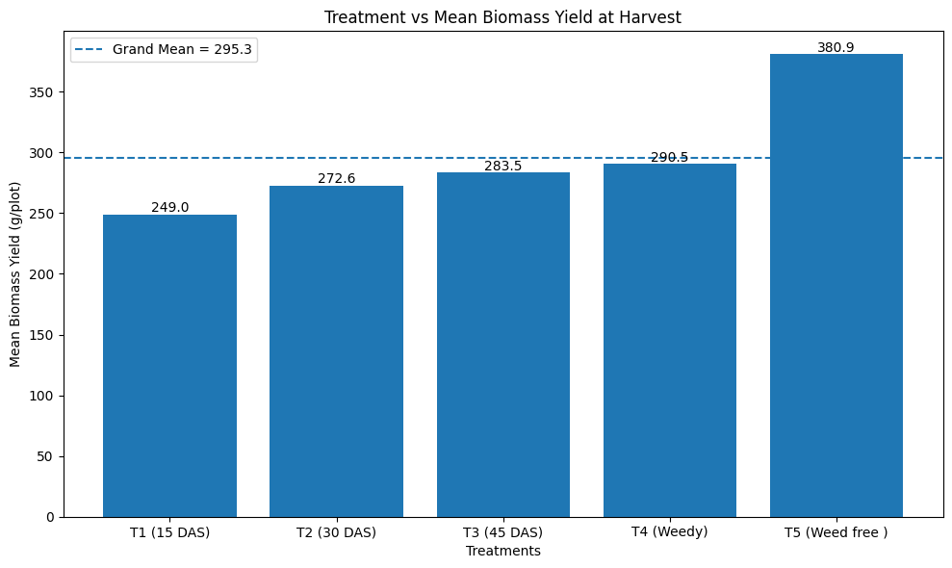

9. Summary and Conclusion

A field experiment was conducted at ZARS, GKVK, UAS Bengaluru during the Rabi season of 2024–25 to study the effect of critical stages of weed competition on the growth and yield parameters of finger millet (Eleusine coracana), variety ML-365. The salient findings of the study are summarized below:

9.1 Key Findings
- The experiment was laid out in RCBD with five treatments (T1–T5) and four replications across 20 plots of 1 m² each.
- ANOVA at 30 DAS showed no statistically significant difference among treatments for plant height (F-cal 0.63 < F-tab 3.26 at 5%), indicating that weed effects were not yet measurable at this early stage.
- By 60 DAS, T5 (weedy throughout) showed the tallest plants (76.83 cm mean), consistent with light-competition-induced stem elongation.
- T4 (weed-free throughout) produced the highest net crop biomass (293.8 g/plot mean), affirming the importance of season-long weed management.
- Total biomass was highest in T5 (322.9 g/plot) due to inclusion of weed biomass, while T1 (weed-free only to 15 DAS) gave the lowest crop biomass (249.0 g/plot).
- The critical period of weed competition was confirmed as approximately 15–45 DAS, beyond which weed-free management yields diminishing returns but maintaining weed control through 45 DAS remains beneficial.

9.2 Conclusion
The results clearly demonstrate that effective weed management during the critical period (15–45 DAS) is essential for optimising finger millet productivity. Weed-free management throughout the season (T4) gives the best crop yield, but targeted management from 30–45 DAS represents a practical and economically viable compromise for resource-limited farmers. T1 (weed-free only to 15 DAS) was the least effective treatment, confirming that a single early weed removal is insufficient to protect yield.

These findings provide practical guidance for farmers and agronomists: at minimum, two rounds of weeding — around 20 DAS and 40 DAS — are recommended for adequate yield protection in finger millet. Integration of pre-emergence herbicide (pendimethalin) with timely manual weeding offers the most cost-effective and efficient approach under Bangalore's Rabi conditions.

10. Future Scope

This experiment opens several important avenues for further research:

- Multi-variety trials: This experiment was conducted with a single variety (ML-365). Future studies should evaluate the critical period across multiple finger millet varieties including improved lines with early vigour, as the CPWC may differ significantly among varieties based on canopy architecture and growth rate.
- Herbicide efficacy evaluation: Systematic comparison of pre-emergence (pendimethalin, atrazine) and post-emergence (2,4-D, penoxsulam) herbicide options with dose optimization studies can identify the most cost-effective chemical weed management strategy tailored to Karnataka's weed flora.
- Weed species dynamics: A detailed weed flora survey and community analysis at different DAS would help identify dominant weed species and their competitive indices, enabling more targeted management recommendations.
- Integrated Weed Management (IWM) systems: Long-term experiments combining cultural practices (denser planting, legume cover crops), mechanical weeding, and herbicide applications in an IWM framework would provide holistic and sustainable recommendations for diverse farming systems.
- Remote sensing and precision weed management: Drone-based NDVI mapping and machine learning-assisted weed detection offer potential for precision weed management in finger millet, reducing labour costs and herbicide use.
- Climate-change resilience: Evaluating weed competition dynamics under elevated CO₂ and temperature scenarios is critical, as climate change is expected to alter weed germination timing and competitive vigour, potentially shifting the critical period window.
- Economic threshold analysis: Detailed benefit-cost ratio analysis of each weed management strategy, including labour costs for manual weeding, would enable development of economic threshold models for weed control decision support.
- Future systems can integrate satellite imagery, drone data, IoT sensors, and weather data for highly accurate crop yield prediction.
- Use of real-time soil health monitoring combined with ML models will improve decision-making at field level.
- Current models are often generalized; future research can focus on location-specific models considering soil type, climate, and cropping systems.
- Custom AI tools for Indian agro-climatic zones will enhance applicability and accuracy.
- • Advanced computer vision and deep learning models can enable real-time identification of weeds using drones or robotic systems.
- • Integration with automated sprayers will allow selective herbicide application, reducing Development of farmer-friendly mobile or web platforms integrating AI to provide:
- Crop yield forecasts
- Weed infestation alerts

- Input recommendations (fertilizers, irrigation, herbicides)
- These systems can improve farm productivity and reduce risks.
- chemical usage and cost.

11. References

1. Gupta, R. D. (2012). Weed Science: Principles and Practices. Oxford & IBH Publishing Co. Pvt. Ltd., New Delhi. [Foundational text on weed biology and management in cereal crops including millets.]

2. Gill, K. K. and Brar, M. S. (2010). Weed Management in Cereals and Pulses. Punjab Agricultural University, Ludhiana. [State-of-art reference on weed control strategies in small millets.]

3. Reddy, T. Y. and Reddi, G. H. S. (2010). Principles of Agronomy (3rd ed.). Kalyani Publishers, Ludhiana. [Comprehensive coverage of crop-wise weed management practices.]

4. ICAR (2018). Handbook of Agriculture (7th ed.). Indian Council of Agricultural Research, New Delhi. [Definitive reference for crop management including finger millet production systems.]

5. UAS Bangalore (2022). Package of Practices for Crops of Karnataka. University of Agricultural Sciences, Bangalore. [Region-specific, updated weed control measures for Karnataka's agroclimatic zones.]

6. Rao, V. S. (2000). Principles of Weed Science (2nd ed.). Science Publishers, USA. [Critical period of weed competition in small millets documented on pp. 210–225.]

7. Subramanian, S., Jaganathan, D. and Kathiresan, G. (2002). Critical period of weed competition in finger millet (Eleusine coracana). Indian Journal of Weed Science, 34(1 & 2): 95–97.

8. Sankaran, N. and Mani, V. S. (2004). Weed management in finger millet: effect of hand weeding and herbicides on weed density and yield. Indian Journal of Agronomy, 49(3): 176–179.

9. Jain, R. K. and Patel, M. M. (2010). Integrated weed management in finger millet (Eleusine coracana). Indian Journal of Weed Science, 42(3 & 4): 175–179.

10. Rana, S. S., Badiyala, D. and Kumar, R. (2015). Weed management in small millets. In: Advances in Agronomy, Vol. 2. Agrobios (India), Jodhpur. Pp. 193–212.

11. Kumar, M., Singh, J. P. and Pant, R. C. (2021). Weed management strategies in organic finger millet cultivation. Journal of Organic Agriculture, 8(2): 44–51.

12. Indian Journal of Weed Science and Indian Journal of Agronomy — Various issues 2010–2023. Published by Indian Society of Weed Science and Indian Society of Agronomy respectively.

